**TECHNICAL UNIVERSITY OF KENYA**

**SCCI/00611/2021**

**RASHID ISAAK JILLO**

**SOFTWARE DEVELOPMENT ASSIGNMENT**

**1**. For this project I will use Agile approach methodology

**2.Context models**

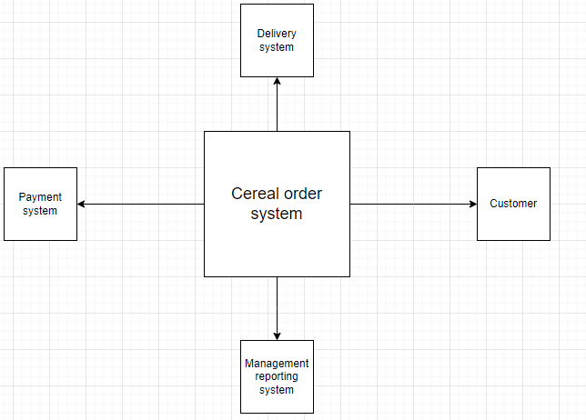

**3.Interaction models**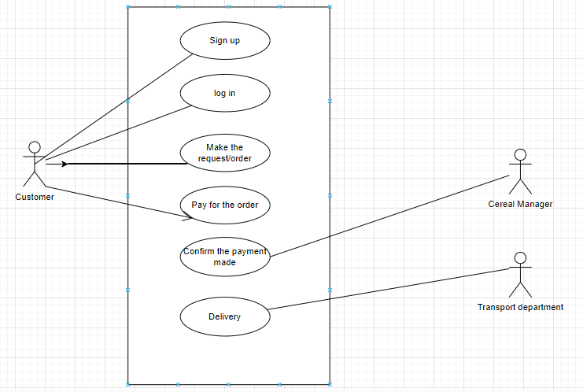

**5.Behavioral model**

